**Comparison of *σ*zz from FEA and analytic results**

1. Bending geometry in FEA



Figure 1: Schematic of bending setup.

The bending setup produces a pure bending stress state far away from two ends of the rod containing two concentric cylinders in figure 1, which will be compared with the analytic results of Jolicoeur *et al*.

2. Elastic properties:

Both layers have cylindrical orthotropic symmetry and the same elastic properties. The “fiber direction” (3-axis) makes an angle of 15° with the *z*-axis of the cylinder. Therefore the elastic constants used in Matlab code should be calculated through the transformation formula of elastic constants.

Table 1: Elastic constants of the cylinders (GPa)



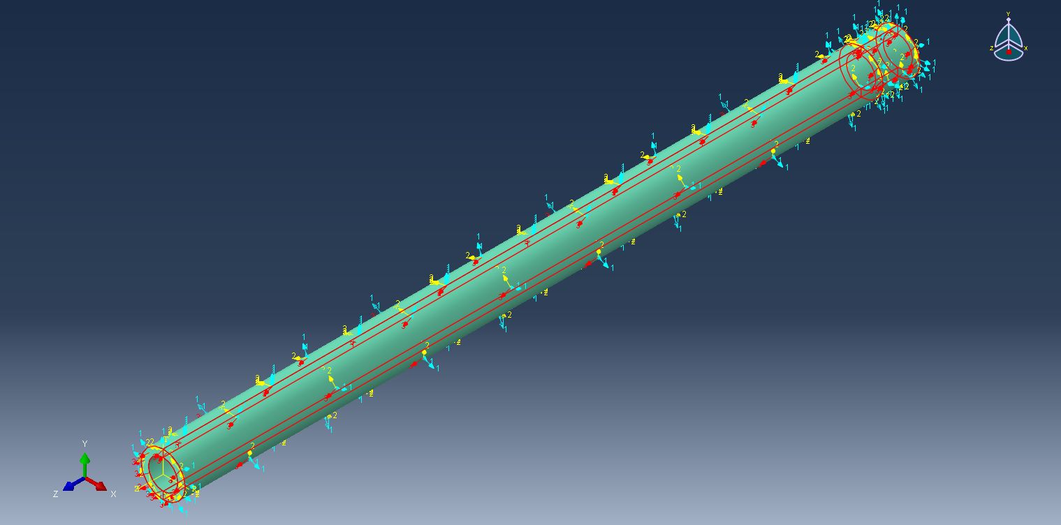

Figure 2: Cylindrical orthotropic property of the cylinder

with the “fiber direction” making an angle of 15° with the z-axis of the cylinder.

3. FEA Results

A moment of 9.5e-6 Nm is applied at the right end of the rod. The stress contour of *σ*zz along the rod (in cylindrical coordinate) and in the cross-section is shown in figure 3. The stress profile within pure bending state remains almost unchanged along *z*-axis, showing that the stress is independent of *z*.

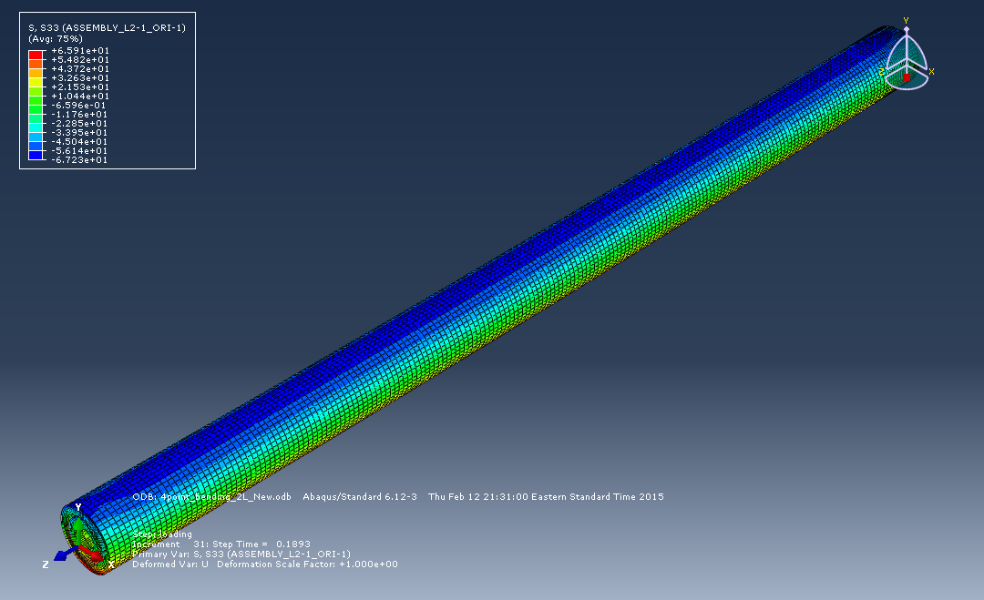

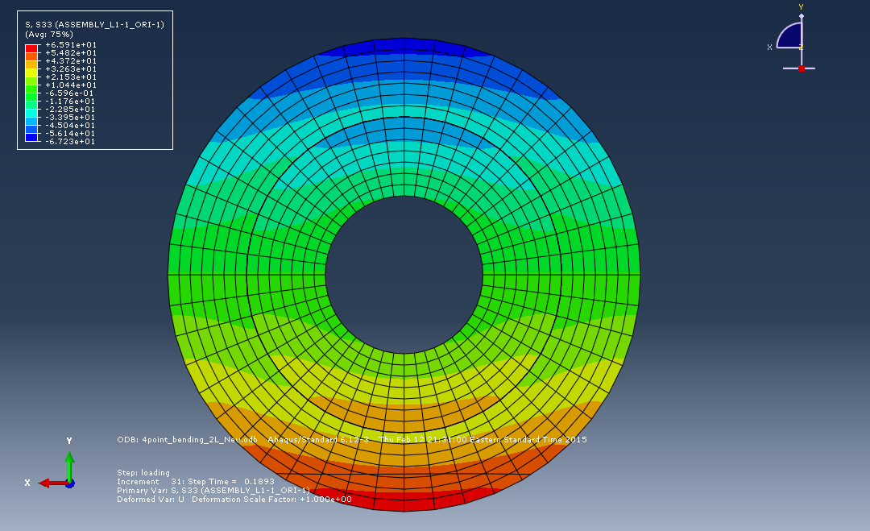

Figure 3: Stress contour of *σ*zz.

4. Comparison with analytic results

Jolicoeur *et al*. gives an analytic solution for the bending problem of anisotropic cylinders with cylindrical orthotropic symmetry, assuming that the deformation is small and stresses and strains are independent of *z*. By using the same parameters in FEA model, we can compare the distribution of *σ*zz from FEA simulation and analytic results, which is shown in figure 4. As we can see, these two results match with each other very well except that there is some difference (~5%) at the interface.



Figure 4: The distribution of *σ*zz calculated from FEA and analytic solution.